Exercise 2: Implementing Dependency Injection

Implementation:

1.pom.xml (Dependency):
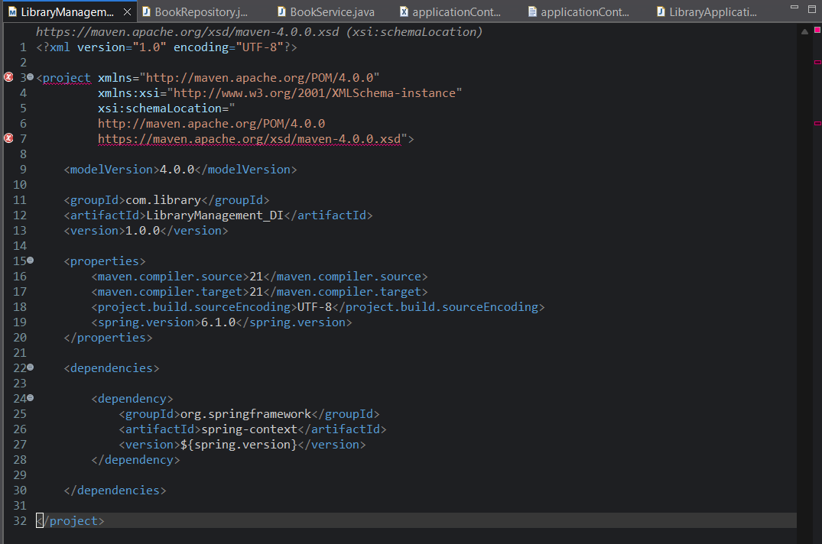

2.BookRepository.java:
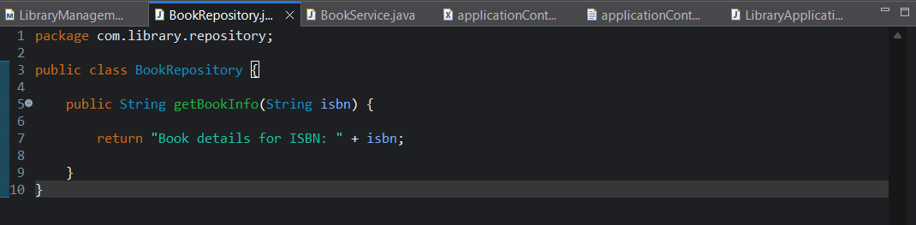

3.BookService.java:
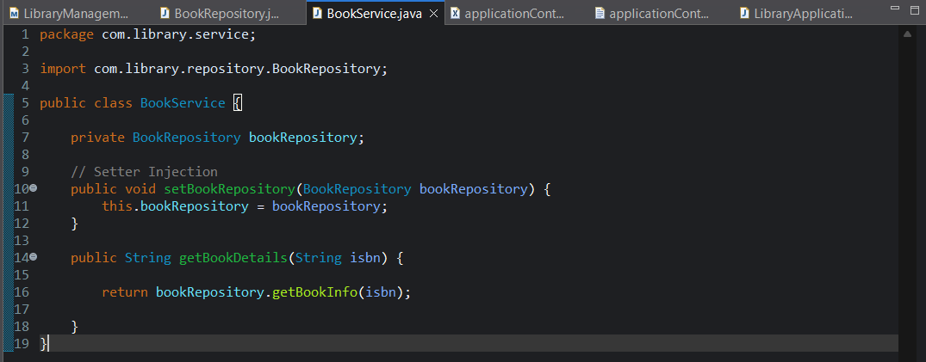

4.applicationContext.xml:
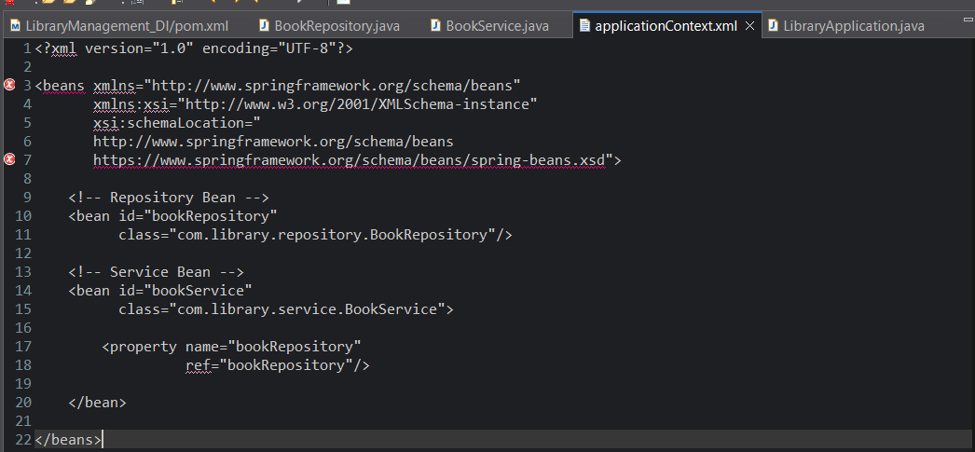

5.LibraryApplication.java:
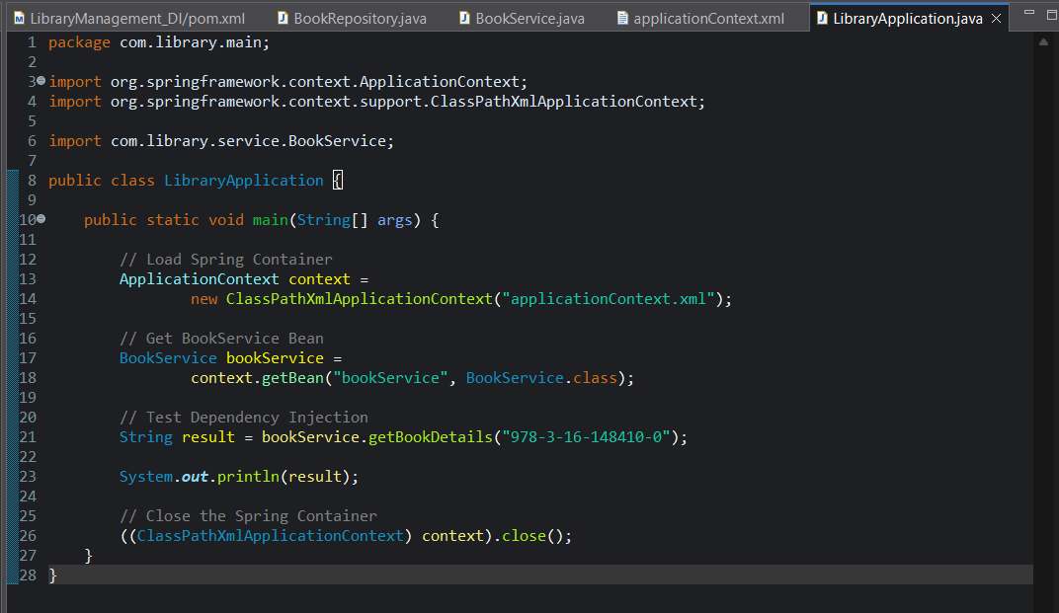

Output:
Book details for ISBN: 978-3-16-148410-0

